While my Final Project was being made I ran into a couple of issues with opening CSV files. Firstly I had issues with only the first row being opened. This was due to the fact that I was using f.readline() and was trying to loop through that… it didn’t work. Ended up switching to csv.reader and turned it into a list. Much less work than what I was planning on doing in the beginning anyway.
This did not last long though as I had an issue with how I was trying to display the csv data. This is a screenshot of that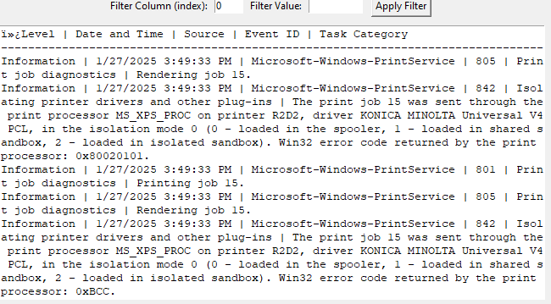
Yeah… it did not look good. So I did some research into how to fix this. Then I discovered that tkinter has themed widgets that I could use. One of these being Treeview. Treeview allowed me to have a more Excel like feel to things while avoiding the 90’s DOS feel that happened when I tried to put it in a text box. Now this added quite a bit of hours onto things but it made everything much much more readable. I used a lot of tutorials for this but the main one was by pythontutorial here.
This was not the only change I needed when I did this though, as you can see in that image vs the current day working one. That being no scroll bar. At first I wanted to be lazy and just have the user resize the window to fit it, but even my main example data would not fit even with the data full screened on my 1440p monitor so I had to fix this too. I saw some people struggling with it online but my goat GeeksforGeeks helped out as per usual (link to guide here just in case) This helped immensely with the readability of the document and was definitely worth it at the end of the day, especially since I want to give this program to a work client specifically for these printlogs (hence why I have been using it in these examples).

